HOMEWORK ASSIGNMENT
Week 6
45 Points Maximum

Name ______________________________________
NETW204
Homework #6
Due Date _____________________________________

Professor ______________________________________

IPv6

- Given the following IPv6 address: 2008:0000:05A3:0000:0000:00FB:0C7A:FE29/64. Simply the address to be optimal in IPv6 (rewrite the address to be the shortest possible IPv6 equivalent address). Explain what you did. (10 points)

- Given the diagram below. Assume the IPv6 prefix is 2005:007D:4500:000C::/64. Find the IPv6 EUI addresses for computers A and B. Show all your work. Do not just copy and paste the final answer to avoid losing points. (20 Points)
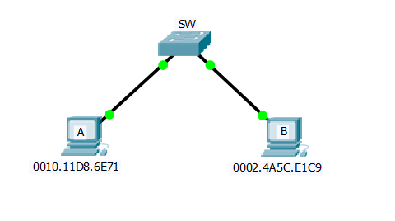

Computer A’s IPv6 EUI Address is:

Computer B’s IPv6 EUI Address is:
- The following IPv6 prefix, 2009:0000:00AF::/48, was assigned to ABC Corporation. You are required to subnet the given network to use a /64 subnet mask. Find the first 15 IPv6 subnets. List the subnets below, one subnet per line. (15 points)

